ASSIGNMENT REPORT

DONE BY:-
VAISHNAVI (192420031)
S. SOUNDHARYA (192421390)
HEMASRINITHA P (192572179)

SMART WATER DISTRIBUTION AND CONSUMPTION ANALYTICS MANAGEMENT SYSTEM USING PYTHON

PSEUDOCODE:-
BEGIN
- Initialize the Tkinter application window.
- Create an empty SET named water_records to store unique water usage records.
- Create the main interface with three modules:
a. Water Distribution and Record Management
b. Consumption Monitoring and Classification
c. Water Analytics and Report Management
MODULE 1 – WATER DISTRIBUTION AND RECORD MANAGEMENT
- Display input fields for:
a. Household or Building ID
b. Zone or Area
c. Water supplied
d. Date
e. Water consumed
- When the user selects ADD RECORD:
a. Read all entered values.
b. Remove unnecessary spaces from text fields.
c. Validate the supplied and consumed water values.
d. Check whether consumption is greater than supplied water.
e. Validate the entered date.
f. Create a record using the collected information.
g. Check whether the record already exists in the SET.
h. If it exists, display a duplicate-record message.
i. Otherwise, insert the record into water_records.
- When DISPLAY RECORDS is selected:
a. Clear the existing table.
b. Read every record from water_records.
c. Calculate the unused water for each record.
d. Determine its consumption category.
e. Display all details in the table.
- When SEARCH is selected:
a. Read the search keyword.
b. Compare it with household ID, zone and date.
c. Collect matching records into another SET.
d. Display the matching records.
- When UPDATE is selected:
a. Select an existing record.
b. Load its values into the input fields.
c. Allow the user to modify the information.
d. Remove the old record from the SET.
e. Insert the modified record as a new unique record.
- When DELETE is selected:
a. Select a record from the table.
b. Ask the user for confirmation.
c. Remove the selected record from water_records.
d. Refresh the table and statistics.
MODULE 2 – CONSUMPTION MONITORING
- Define a consumption classification function.
- For every record:
a. If consumption is within the lower limit, classify it as LOW.
b. If consumption falls within the middle range, classify it as MODERATE.
c. Otherwise, classify it as HIGH.
- When CLASSIFICATION is selected:
a. Count the number of low, moderate and high users.
b. Display the classification summary.
c. Display the corresponding household details.
- When EXCESSIVE CONSUMPTION is selected:
a. Ask the user to enter a consumption limit.
b. Compare each record's consumption with the limit.
c. Store records exceeding the limit.
d. Display the households with excessive consumption.
- When ZONE ANALYSIS is selected:
a. Create a SET containing unique zones.
b. For every zone, calculate total consumption.
c. Count the number of users in each zone.
d. Display zone-wise consumption results.
e. Identify the zone with the highest consumption.
- When UNIQUE DATA is selected:
a. Create a SET of unique household IDs.
b. Create a SET of unique zones.
c. Create a SET of consumption categories.
d. Display the unique values.
MODULE 3 – WATER ANALYTICS AND REPORT MANAGEMENT
- Calculate the following values:
a. Total water supplied
b. Total water consumed
c. Remaining water
d. Average consumption
e. Consumption percentage
f. Number of high-consumption users
- When WATER ANALYSIS is selected:
a. Perform the calculations using all stored records.
b. Display the calculated results.
c. Display a suitable water usage status.
- When SAVE DATA is selected:
a. Open a text file.
b. Convert each SET record into a storable format.
c. Write all records into the file.
d. Close the file.
e. Display a successful save message.
- When LOAD DATA is selected:
a. Check whether the data file exists.
b. Open the file.
c. Read each stored line.
d. Convert the values back into the required data types.
e. Insert the records into water_records.
f. Refresh the table and dashboard.
- When GENERATE REPORT is selected:
a. Calculate all major water statistics.
b. Calculate consumption categories.
c. Find unique zones.
d. Write the results into a report file.
e. Include detailed water records.
f. Close the report file.
g. Display a confirmation message.
- When EXPORT REPORT is selected:
a. Ask the user for a destination.
b. Create a text report containing the calculated results.
c. Write the stored records and analysis.
d. Save the report at the selected location.
- Continuously update the dashboard statistics whenever records are added,
modified, deleted or loaded.
- Keep the Tkinter application active until the user closes the window.
END

SOURCE CODE:-
import tkinter as tk
from tkinter import ttk,messagebox,filedialog
from datetime import datetime
import os
water_records=set()
DATA_FILE="water_records.txt"
REPORT_FILE="water_report.txt"
BG="#071A2B"
SIDEBAR="#0B263D"
PANEL="#0E3047"
CARD="#123B54"
ENTRY_BG="#092338"
CYAN="#19D3C5"
PURPLE="#8A6CFF"
BLUE="#3EA6FF"
GREEN="#35D07F"
YELLOW="#FFC857"
RED="#FF5D73"
WHITE="#F4FAFF"
LIGHT="#C7DCE8"
GRAY="#8FAABD"
root=tk.Tk()
root.title("Smart Water Distribution and Consumption Analytics Management System")
root.geometry("1400x800")
root.minsize(1100,650)
root.configure(bg=BG)
try:
root.state("zoomed")
except:
pass
style=ttk.Style()
try:
style.theme_use("clam")
except:
pass
style.configure("Treeview",background=ENTRY_BG,foreground=WHITE,fieldbackground=ENTRY_BG,rowheight=34,font=("Segoe UI",10))
style.configure("Treeview.Heading",background=PURPLE,foreground=WHITE,font=("Segoe UI",10,"bold"),padding=7)
style.map("Treeview",background=[("selected",CYAN)],foreground=[("selected",BG)])
page_title=tk.StringVar(value="Water Distribution & Record Management")
page_description=tk.StringVar(value="Module 1 • Manage household and community water records")
total_records_var=tk.StringVar(value="0")
total_supply_var=tk.StringVar(value="0 L")
total_consumption_var=tk.StringVar(value="0 L")
remaining_var=tk.StringVar(value="0 L")
average_var=tk.StringVar(value="0 L")
percentage_var=tk.StringVar(value="0%")
def clean_text(value):
return value.strip()
def number_value(value):
try:
number=float(value.strip())
if number<0:
return None
return number
except ValueError:
return None
def classify_consumption(amount):
if amount<=500:
return "Low Consumption"
elif amount<=1000:
return "Moderate Consumption"
else:
return "High Consumption"
def format_value(value):
if float(value).is_integer():
return f"{int(value):,}"
return f"{value:,.2f}"
def update_statistics():
total_supply=sum(record[2] for record in water_records)
total_consumption=sum(record[4] for record in water_records)
remaining=total_supply-total_consumption
average=total_consumption/len(water_records) if water_records else 0
percentage=(total_consumption/total_supply)*100 if total_supply>0 else 0
total_records_var.set(str(len(water_records)))
total_supply_var.set(format_value(total_supply)+" L")
total_consumption_var.set(format_value(total_consumption)+" L")
remaining_var.set(format_value(remaining)+" L")
average_var.set(format_value(average)+" L")
percentage_var.set(f"{percentage:.1f}%")
def clear_table():
for item in records_table.get_children():
records_table.delete(item)
def display_records(records=None):
clear_table()
if records is None:
records=water_records
for record in sorted(records):
household_id=record[0]
zone=record[1]
supplied=record[2]
date=record[3]
consumed=record[4]
remaining=supplied-consumed
category=classify_consumption(consumed)
records_table.insert("", "end", values=(household_id,zone,f"{supplied:.2f}",date,f"{consumed:.2f}",f"{remaining:.2f}",category))
update_statistics()
result_label.config(text=f"{len(records)} record(s) displayed")
def add_water_record():
household_id=clean_text(id_entry.get())
zone=clean_text(zone_entry.get())
supplied_text=clean_text(supplied_entry.get())
date=clean_text(date_entry.get())
consumed_text=clean_text(consumed_entry.get())
if not household_id:
messagebox.showwarning("Missing Data","Please enter Household / Building ID.")
return
if not zone:
messagebox.showwarning("Missing Data","Please enter the area or zone.")
return
supplied=number_value(supplied_text)
consumed=number_value(consumed_text)
if supplied is None or supplied<=0:
messagebox.showerror("Invalid Supply","Water supplied must be a positive number.")
return
if consumed is None:
messagebox.showerror("Invalid Consumption","Enter a valid water consumption value.")
return
if consumed>supplied:
messagebox.showerror("Invalid Record","Consumption cannot be greater than supplied water.")
return
try:
datetime.strptime(date,"%d-%m-%Y")
except ValueError:
messagebox.showerror("Invalid Date","Use the format DD-MM-YYYY.")
return
new_record=(household_id.upper(),zone.title(),supplied,date,consumed)
if new_record in water_records:
messagebox.showwarning("Duplicate Record","This exact record already exists.")
return
water_records.add(new_record)
display_records()
clear_inputs()
messagebox.showinfo("Success","Water distribution record added successfully.")
def clear_inputs():
id_entry.delete(0,tk.END)
zone_entry.delete(0,tk.END)
supplied_entry.delete(0,tk.END)
consumed_entry.delete(0,tk.END)
date_entry.delete(0,tk.END)
date_entry.insert(0,datetime.now().strftime("%d-%m-%Y"))
def search_water_records():
keyword=clean_text(search_entry.get()).lower()
if not keyword:
display_records()
return
matching_records=set()
for record in water_records:
if keyword in record[0].lower() or keyword in record[1].lower() or keyword in record[3].lower():
matching_records.add(record)
display_records(matching_records)
def show_all_records():
search_entry.delete(0,tk.END)
display_records()
def delete_selected_record():
selected=records_table.selection()
if not selected:
messagebox.showwarning("No Selection","Please select a record from the table.")
return
values=records_table.item(selected[0])["values"]
target=(values[0],values[1],float(values[2]),values[3],float(values[4]))
confirmation=messagebox.askyesno("Delete Record",f"Do you want to delete record {values[0]}?")
if confirmation:
if target in water_records:
water_records.remove(target)
display_records()
messagebox.showinfo("Deleted","Record deleted successfully.")
def update_selected_record():
selected=records_table.selection()
if not selected:
messagebox.showwarning("No Selection","Select a record before updating.")
return
values=records_table.item(selected[0])["values"]
old_record=(values[0],values[1],float(values[2]),values[3],float(values[4]))
if old_record not in water_records:
messagebox.showerror("Error","The selected record could not be found.")
return
id_entry.delete(0,tk.END)
id_entry.insert(0,values[0])
zone_entry.delete(0,tk.END)
zone_entry.insert(0,values[1])
supplied_entry.delete(0,tk.END)
supplied_entry.insert(0,values[2])
date_entry.delete(0,tk.END)
date_entry.insert(0,values[3])
consumed_entry.delete(0,tk.END)
consumed_entry.insert(0,values[4])
water_records.remove(old_record)
display_records()
messagebox.showinfo("Edit Mode","Modify the values and click ADD RECORD to save the updated record.")
def classification_window():
window=tk.Toplevel(root)
window.title("Consumption Classification")
window.geometry("850x600")
window.configure(bg=BG)
tk.Label(window,text="Consumption Classification",font=("Segoe UI",22,"bold"),bg=BG,fg=WHITE).pack(pady=20)
low_count=0
moderate_count=0
high_count=0
for record in water_records:
category=classify_consumption(record[4])
if category=="Low Consumption":
low_count+=1
elif category=="Moderate Consumption":
moderate_count+=1
else:
high_count+=1
summary=tk.Frame(window,bg=PANEL)
summary.pack(fill="x",padx=30,pady=10)
data=[("LOW",low_count,GREEN),("MODERATE",moderate_count,YELLOW),("HIGH",high_count,RED)]
for title,value,color in data:
frame=tk.Frame(summary,bg=CARD)
frame.pack(side="left",expand=True,fill="both",padx=7,pady=10)
tk.Label(frame,text=title,font=("Segoe UI",11,"bold"),bg=CARD,fg=GRAY).pack(pady=(10,2))
tk.Label(frame,text=str(value),font=("Segoe UI",23,"bold"),bg=CARD,fg=color).pack(pady=(0,10))
tree=ttk.Treeview(window,columns=("ID","Zone","Consumption","Classification"),show="headings")
tree.heading("ID",text="Household ID")
tree.heading("Zone",text="Zone")
tree.heading("Consumption",text="Consumption")
tree.heading("Classification",text="Classification")
tree.column("ID",width=170)
tree.column("Zone",width=170)
tree.column("Consumption",width=190)
tree.column("Classification",width=220)
tree.pack(fill="both",expand=True,padx=30,pady=15)
for record in sorted(water_records):
tree.insert("","end",values=(record[0],record[1],f"{record[4]:,.2f} L",classify_consumption(record[4])))
def excessive_consumption_window():
window=tk.Toplevel(root)
window.title("Excessive Consumption")
window.geometry("520x350")
window.configure(bg=BG)
tk.Label(window,text="Excessive Consumption",font=("Segoe UI",21,"bold"),bg=BG,fg=WHITE).pack(pady=25)
tk.Label(window,text="Maximum acceptable consumption (Litres)",font=("Segoe UI",11),bg=BG,fg=LIGHT).pack(pady=5)
limit_entry=tk.Entry(window,font=("Segoe UI",13),bg=ENTRY_BG,fg=WHITE,insertbackground=WHITE,relief="flat")
limit_entry.pack(fill="x",padx=60,ipady=8)
def detect():
limit=number_value(limit_entry.get())
if limit is None:
messagebox.showerror("Invalid Limit","Enter a valid numerical limit.")
return
excessive={record for record in water_records if record[4]>limit}
window.destroy()
result_window=tk.Toplevel(root)
result_window.title("Excessive Consumption Results")
result_window.geometry("750x500")
result_window.configure(bg=BG)
tk.Label(result_window,text=f"Users Above {limit:,.2f} Litres",font=("Segoe UI",20,"bold"),bg=BG,fg=WHITE).pack(pady=20)
tree=ttk.Treeview(result_window,columns=("ID","Zone","Consumption"),show="headings")
tree.heading("ID",text="Household ID")
tree.heading("Zone",text="Zone")
tree.heading("Consumption",text="Consumption")
tree.pack(fill="both",expand=True,padx=30,pady=15)
for record in sorted(excessive):
tree.insert("","end",values=(record[0],record[1],f"{record[4]:,.2f} L"))
tk.Label(result_window,text=f"{len(excessive)} excessive user(s) detected",font=("Segoe UI",12,"bold"),bg=BG,fg=RED).pack(pady=10)
tk.Button(window,text="DETECT",command=detect,font=("Segoe UI",11,"bold"),bg=RED,fg=WHITE,relief="flat",cursor="hand2",padx=30,pady=10).pack(pady=25)
def zone_analysis_window():
zones={record[1] for record in water_records}
zone_data={}
for zone in zones:
zone_data[zone]=sum(record[4] for record in water_records if record[1]==zone)
window=tk.Toplevel(root)
window.title("Zone-wise Analysis")
window.geometry("750x550")
window.configure(bg=BG)
tk.Label(window,text="Zone-wise Consumption Analysis",font=("Segoe UI",21,"bold"),bg=BG,fg=WHITE).pack(pady=20)
tree=ttk.Treeview(window,columns=("Zone","Users","Consumption"),show="headings")
tree.heading("Zone",text="Zone")
tree.heading("Users",text="Users")
tree.heading("Consumption",text="Total Consumption")
tree.pack(fill="both",expand=True,padx=30,pady=15)
for zone in sorted(zones):
user_count=sum(1 for record in water_records if record[1]==zone)
tree.insert("","end",values=(zone,user_count,f"{zone_data[zone]:,.2f} L"))
if zone_data:
highest_zone=max(zone_data,key=zone_data.get)
tk.Label(window,text=f"Highest Consumption Zone: {highest_zone} ({zone_data[highest_zone]:,.2f} L)",font=("Segoe UI",12,"bold"),bg=BG,fg=YELLOW).pack(pady=12)
def unique_data_window():
unique_users={record[0] for record in water_records}
unique_zones={record[1] for record in water_records}
unique_categories={classify_consumption(record[4]) for record in water_records}
window=tk.Toplevel(root)
window.title("Unique Data Analysis")
window.geometry("800x550")
window.configure(bg=BG)
tk.Label(window,text="Unique Data Analysis Using Sets",font=("Segoe UI",21,"bold"),bg=BG,fg=WHITE).pack(pady=20)
information=[("UNIQUE HOUSEHOLDS",unique_users),("UNIQUE ZONES",unique_zones),("CONSUMPTION CATEGORIES",unique_categories)]
for heading,values in information:
frame=tk.Frame(window,bg=PANEL)
frame.pack(fill="x",padx=35,pady=7)
tk.Label(frame,text=heading,font=("Segoe UI",11,"bold"),bg=PANEL,fg=CYAN).pack(anchor="w",padx=15,pady=(10,3))
text=", ".join(sorted(values)) if values else "No data available"
tk.Label(frame,text=text,font=("Segoe UI",11),bg=PANEL,fg=WHITE,wraplength=700,justify="left").pack(anchor="w",padx=15,pady=(0,10))
def analytics_window():
total_supply=sum(record[2] for record in water_records)
total_consumption=sum(record[4] for record in water_records)
remaining=total_supply-total_consumption
average=total_consumption/len(water_records) if water_records else 0
percentage=total_consumption/total_supply*100 if total_supply>0 else 0
high_users=sum(1 for record in water_records if classify_consumption(record[4])=="High Consumption")
window=tk.Toplevel(root)
window.title("Water Analytics")
window.geometry("800x600")
window.configure(bg=BG)
tk.Label(window,text="Water Consumption Analytics",font=("Segoe UI",22,"bold"),bg=BG,fg=WHITE).pack(pady=20)
values=[("Total Water Supplied",f"{total_supply:,.2f} L"),("Total Water Consumed",f"{total_consumption:,.2f} L"),("Remaining Water",f"{remaining:,.2f} L"),("Average Consumption",f"{average:,.2f} L"),("Consumption Percentage",f"{percentage:.2f}%"),("High Consumption Users",str(high_users))]
panel=tk.Frame(window,bg=PANEL)
panel.pack(fill="x",padx=40)
for label,value in values:
row=tk.Frame(panel,bg=PANEL)
row.pack(fill="x",padx=20,pady=8)
tk.Label(row,text=label,font=("Segoe UI",12),bg=PANEL,fg=LIGHT).pack(side="left")
tk.Label(row,text=value,font=("Segoe UI",13,"bold"),bg=PANEL,fg=CYAN).pack(side="right")
if percentage>=80:
status="WARNING: Water consumption is very high."
status_color=RED
elif percentage>=60:
status="NOTICE: Consumption requires monitoring."
status_color=YELLOW
else:
status="STATUS: Water usage is within the monitored range."
status_color=GREEN
tk.Label(window,text=status,font=("Segoe UI",12,"bold"),bg=BG,fg=status_color).pack(pady=25)
def save_water_data():
try:
with open(DATA_FILE,"w",encoding="utf-8") as file:
for record in sorted(water_records):
file.write("|".join([record[0],record[1],str(record[2]),record[3],str(record[4])])+"\n")
messagebox.showinfo("Data Saved",f"{len(water_records)} record(s) saved successfully.")
except OSError as error:
messagebox.showerror("File Error",str(error))
def load_water_data():
if not os.path.exists(DATA_FILE):
messagebox.showinfo("No File","No previously saved data was found.")
return
loaded_records=set()
try:
with open(DATA_FILE,"r",encoding="utf-8") as file:
for line in file:
line=line.strip()
if not line:
continue
parts=line.split("|")
if len(parts)!=5:
continue
record=(parts[0],parts[1],float(parts[2]),parts[3],float(parts[4]))
loaded_records.add(record)
water_records.clear()
water_records.update(loaded_records)
display_records()
messagebox.showinfo("Data Loaded",f"{len(water_records)} record(s) loaded successfully.")
except (OSError,ValueError) as error:
messagebox.showerror("Load Error",str(error))
def generate_report():
total_supply=sum(record[2] for record in water_records)
total_consumption=sum(record[4] for record in water_records)
remaining=total_supply-total_consumption
average=total_consumption/len(water_records) if water_records else 0
percentage=total_consumption/total_supply*100 if total_supply else 0
low=sum(1 for record in water_records if classify_consumption(record[4])=="Low Consumption")
moderate=sum(1 for record in water_records if classify_consumption(record[4])=="Moderate Consumption")
high=sum(1 for record in water_records if classify_consumption(record[4])=="High Consumption")
unique_zones={record[1] for record in water_records}
try:
with open(REPORT_FILE,"w",encoding="utf-8") as file:
file.write("SMART WATER DISTRIBUTION AND CONSUMPTION\n")
file.write("ANALYTICAL MANAGEMENT REPORT\n")
file.write("="*60+"\n\n")
file.write("Generated On: "+datetime.now().strftime("%d-%m-%Y %H:%M:%S")+"\n\n")
file.write("WATER ANALYSIS\n")
file.write("-"*40+"\n")
file.write(f"Total Records : {len(water_records)}\n")
file.write(f"Total Water Supplied : {total_supply:.2f} L\n")
file.write(f"Total Water Consumed : {total_consumption:.2f} L\n")
file.write(f"Remaining Water : {remaining:.2f} L\n")
file.write(f"Average Consumption : {average:.2f} L\n")
file.write(f"Consumption Percentage : {percentage:.2f}%\n\n")
file.write("CONSUMPTION CLASSIFICATION\n")
file.write("-"*40+"\n")
file.write(f"Low Consumption : {low}\n")
file.write(f"Moderate Consumption : {moderate}\n")
file.write(f"High Consumption : {high}\n\n")
file.write("UNIQUE ZONES\n")
file.write("-"*40+"\n")
for zone in sorted(unique_zones):
file.write(zone+"\n")
file.write("\nDETAILED RECORDS\n")
file.write("-"*80+"\n")
for record in sorted(water_records):
file.write(f"ID: {record[0]} | Zone: {record[1]} | Supplied: {record[2]:.2f} L | Date: {record[3]} | Consumed: {record[4]:.2f} L | Category: {classify_consumption(record[4])}\n")
messagebox.showinfo("Report Generated",f"Report generated successfully.\n\nFile: {REPORT_FILE}")
except OSError as error:
messagebox.showerror("Report Error",str(error))
def export_report():
if not water_records:
messagebox.showwarning("No Data","Add records before exporting.")
return
destination=filedialog.asksaveasfilename(title="Export Water Report",defaultextension=".txt",filetypes=[("Text Files","*.txt"),("All Files","*.*")])
if not destination:
return
total_supply=sum(record[2] for record in water_records)
total_consumption=sum(record[4] for record in water_records)
remaining=total_supply-total_consumption
average=total_consumption/len(water_records)
percentage=total_consumption/total_supply*100 if total_supply else 0
try:
with open(destination,"w",encoding="utf-8") as file:
file.write("SMART WATER MANAGEMENT REPORT\n")
file.write("="*60+"\n\n")
file.write(f"Generated: {datetime.now().strftime('%d-%m-%Y %H:%M:%S')}\n\n")
file.write(f"Total Records: {len(water_records)}\n")
file.write(f"Total Supplied: {total_supply:.2f} L\n")
file.write(f"Total Consumed: {total_consumption:.2f} L\n")
file.write(f"Remaining Water: {remaining:.2f} L\n")
file.write(f"Average Consumption: {average:.2f} L\n")
file.write(f"Consumption Percentage: {percentage:.2f}%\n\n")
file.write("RECORD DETAILS\n")
file.write("-"*60+"\n")
for record in sorted(water_records):
file.write(f"{record[0]} | {record[1]} | {record[2]:.2f} L | {record[3]} | {record[4]:.2f} L | {classify_consumption(record[4])}\n")
messagebox.showinfo("Export Complete","Report exported successfully.")
except OSError as error:
messagebox.showerror("Export Error",str(error))
def activate_module(number):
if number==1:
page_title.set("Water Distribution & Record Management")
page_description.set("Module 1 • Add, search, display, update and delete water records")
module1_frame.tkraise()
elif number==2:
page_title.set("Consumption Monitoring & Classification")
page_description.set("Module 2 • Monitor consumption levels, zones and excessive usage")
module2_frame.tkraise()
elif number==3:
page_title.set("Water Analytics & Report Management")
page_description.set("Module 3 • Analyze water usage and manage analytical reports")
module3_frame.tkraise()
sidebar=tk.Frame(root,bg=SIDEBAR,width=250)
sidebar.pack(side="left",fill="y")
sidebar.pack_propagate(False)
tk.Label(sidebar,text="SMART WATER",font=("Segoe UI",21,"bold"),bg=SIDEBAR,fg=CYAN).pack(pady=(30,2))
tk.Label(sidebar,text="MANAGEMENT SYSTEM",font=("Segoe UI",9,"bold"),bg=SIDEBAR,fg=GRAY).pack(pady=(0,25))
def sidebar_button(text,command,color):
button=tk.Button(sidebar,text=text,command=command,font=("Segoe UI",10,"bold"),bg=SIDEBAR,fg=color,activebackground=PANEL,activeforeground=color,relief="flat",cursor="hand2",anchor="w",padx=18,pady=11)
button.pack(fill="x",padx=8,pady=3)
sidebar_button("MODULE 1 | DATA",lambda:activate_module(1),CYAN)
sidebar_button("MODULE 2 | CONSUMPTION",lambda:activate_module(2),PURPLE)
sidebar_button("MODULE 3 | ANALYTICS",lambda:activate_module(3),YELLOW)
tk.Frame(sidebar,bg=SIDEBAR,height=15).pack()
sidebar_button("SAVE WATER DATA",save_water_data,GREEN)
sidebar_button("LOAD WATER DATA",load_water_data,BLUE)
sidebar_button("GENERATE REPORT",generate_report,YELLOW)
bottom_info=tk.Frame(sidebar,bg=SIDEBAR)
bottom_info.pack(side="bottom",pady=15)
tk.Label(bottom_info,text="TEAM 4",font=("Segoe UI",12,"bold"),bg=SIDEBAR,fg=WHITE).pack()
tk.Label(bottom_info,text="PRIMARY DATA STRUCTURE",font=("Segoe UI",8),bg=SIDEBAR,fg=GRAY).pack(pady=(3,0))
tk.Label(bottom_info,text="SET",font=("Segoe UI",11,"bold"),bg=SIDEBAR,fg=CYAN).pack()
content=tk.Frame(root,bg=BG)
content.pack(side="left",fill="both",expand=True)
header=tk.Frame(content,bg=BG)
header.pack(fill="x",padx=25,pady=(18,5))
tk.Label(header,textvariable=page_title,font=("Segoe UI",22,"bold"),bg=BG,fg=WHITE).pack(anchor="w")
tk.Label(header,textvariable=page_description,font=("Segoe UI",10),bg=BG,fg=GRAY).pack(anchor="w",pady=(3,0))
statistics=tk.Frame(content,bg=BG)
statistics.pack(fill="x",padx=20,pady=7)
def create_stat_card(title,variable,accent):
card=tk.Frame(statistics,bg=CARD,highlightthickness=1,highlightbackground=accent)
card.pack(side="left",fill="both",expand=True,padx=4)
tk.Label(card,text=title,font=("Segoe UI",8,"bold"),bg=CARD,fg=GRAY).pack(pady=(8,2))
tk.Label(card,textvariable=variable,font=("Segoe UI",15,"bold"),bg=CARD,fg=accent).pack(pady=(0,8))
create_stat_card("RECORDS",total_records_var,CYAN)
create_stat_card("SUPPLIED",total_supply_var,BLUE)
create_stat_card("CONSUMED",total_consumption_var,PURPLE)
create_stat_card("REMAINING",remaining_var,GREEN)
create_stat_card("AVERAGE",average_var,YELLOW)
create_stat_card("CONSUMPTION %",percentage_var,RED)
module_container=tk.Frame(content,bg=BG)
module_container.pack(fill="both",expand=True,padx=20,pady=5)
module1_frame=tk.Frame(module_container,bg=BG)
module2_frame=tk.Frame(module_container,bg=BG)
module3_frame=tk.Frame(module_container,bg=BG)
for frame in (module1_frame,module2_frame,module3_frame):
frame.place(relx=0,rely=0,relwidth=1,relheight=1)
module1_left=tk.Frame(module1_frame,bg=PANEL,width=315)
module1_left.pack(side="left",fill="y",padx=(0,8))
module1_left.pack_propagate(False)
tk.Label(module1_left,text="ADD WATER RECORD",font=("Segoe UI",15,"bold"),bg=PANEL,fg=WHITE).pack(pady=(15,10))
def input_field(parent,label):
tk.Label(parent,text=label,font=("Segoe UI",9,"bold"),bg=PANEL,fg=LIGHT).pack(anchor="w",padx=18,pady=(5,2))
entry=tk.Entry(parent,font=("Segoe UI",11),bg=ENTRY_BG,fg=WHITE,insertbackground=WHITE,relief="flat")
entry.pack(fill="x",padx=18,ipady=6)
return entry
id_entry=input_field(module1_left,"Household / Building ID")
zone_entry=input_field(module1_left,"Area / Zone")
supplied_entry=input_field(module1_left,"Water Supplied (Litres)")
date_entry=input_field(module1_left,"Date (DD-MM-YYYY)")
consumed_entry=input_field(module1_left,"Water Consumption (Litres)")
date_entry.insert(0,datetime.now().strftime("%d-%m-%Y"))
tk.Button(module1_left,text="ADD RECORD",command=add_water_record,font=("Segoe UI",10,"bold"),bg=CYAN,fg=BG,relief="flat",cursor="hand2",pady=8).pack(fill="x",padx=18,pady=(12,4))
tk.Button(module1_left,text="UPDATE SELECTED",command=update_selected_record,font=("Segoe UI",10,"bold"),bg=PURPLE,fg=WHITE,relief="flat",cursor="hand2",pady=8).pack(fill="x",padx=18,pady=3)
tk.Button(module1_left,text="CLEAR INPUTS",command=clear_inputs,font=("Segoe UI",10,"bold"),bg=CARD,fg=WHITE,relief="flat",cursor="hand2",pady=8).pack(fill="x",padx=18,pady=3)
module1_right=tk.Frame(module1_frame,bg=PANEL)
module1_right.pack(side="left",fill="both",expand=True)
search_frame=tk.Frame(module1_right,bg=PANEL)
search_frame.pack(fill="x",padx=15,pady=10)
tk.Label(search_frame,text="SEARCH",font=("Segoe UI",10,"bold"),bg=PANEL,fg=WHITE).pack(side="left")
search_entry=tk.Entry(search_frame,font=("Segoe UI",11),bg=ENTRY_BG,fg=WHITE,insertbackground=WHITE,relief="flat")
search_entry.pack(side="left",fill="x",expand=True,padx=8,ipady=6)
tk.Button(search_frame,text="SEARCH",command=search_water_records,font=("Segoe UI",9,"bold"),bg=CYAN,fg=BG,relief="flat",cursor="hand2",padx=12,pady=7).pack(side="left")
tk.Button(search_frame,text="SHOW ALL",command=show_all_records,font=("Segoe UI",9,"bold"),bg=PURPLE,fg=WHITE,relief="flat",cursor="hand2",padx=12,pady=7).pack(side="left",padx=5)
result_label=tk.Label(module1_right,text="0 record(s) displayed",font=("Segoe UI",9),bg=PANEL,fg=GRAY)
result_label.pack(anchor="w",padx=15)
table_area=tk.Frame(module1_right,bg=PANEL)
table_area.pack(fill="both",expand=True,padx=15,pady=5)
records_table=ttk.Treeview(table_area,columns=("ID","Zone","Supplied","Date","Consumed","Remaining","Category"),show="headings")
headings={"ID":"Household ID","Zone":"Zone","Supplied":"Supplied","Date":"Date","Consumed":"Consumed","Remaining":"Remaining","Category":"Classification"}
for column in headings:
records_table.heading(column,text=headings[column])
records_table.column(column,width=100,anchor="center")
scrollbar=ttk.Scrollbar(table_area,orient="vertical",command=records_table.yview)
records_table.configure(yscrollcommand=scrollbar.set)
records_table.pack(side="left",fill="both",expand=True)
scrollbar.pack(side="right",fill="y")
tk.Button(module1_right,text="DELETE SELECTED RECORD",command=delete_selected_record,font=("Segoe UI",9,"bold"),bg=RED,fg=WHITE,relief="flat",cursor="hand2",padx=12,pady=7).pack(anchor="e",padx=15,pady=7)
tk.Label(module2_frame,text="CONSUMPTION MONITORING",font=("Segoe UI",22,"bold"),bg=BG,fg=WHITE).pack(pady=(15,3))
tk.Label(module2_frame,text="Monitor consumption levels, excessive usage, zones and unique data",font=("Segoe UI",10),bg=BG,fg=GRAY).pack(pady=(0,15))
module2_buttons=tk.Frame(module2_frame,bg=BG)
module2_buttons.pack(fill="x",padx=25)
def large_action_button(parent,title,description,command,color):
frame=tk.Frame(parent,bg=CARD,highlightthickness=1,highlightbackground=color)
frame.pack(side="left",fill="both",expand=True,padx=5,pady=5)
tk.Label(frame,text=title,font=("Segoe UI",13,"bold"),bg=CARD,fg=color).pack(pady=(15,4))
tk.Label(frame,text=description,font=("Segoe UI",9),bg=CARD,fg=LIGHT,wraplength=180).pack(pady=4)
tk.Button(frame,text="OPEN",command=command,font=("Segoe UI",9,"bold"),bg=color,fg=BG,relief="flat",cursor="hand2",padx=15,pady=7).pack(pady=12)
large_action_button(module2_buttons,"CLASSIFICATION","Identify low, moderate and high consumption users.",classification_window,CYAN)
large_action_button(module2_buttons,"EXCESSIVE USE","Find users whose consumption exceeds a selected limit.",excessive_consumption_window,RED)
large_action_button(module2_buttons,"ZONE ANALYSIS","Compare water consumption between different zones.",zone_analysis_window,YELLOW)
large_action_button(module2_buttons,"UNIQUE DATA","Identify unique users, zones and categories using Sets.",unique_data_window,GREEN)
tk.Label(module3_frame,text="WATER ANALYTICS & REPORT MANAGEMENT",font=("Segoe UI",22,"bold"),bg=BG,fg=WHITE).pack(pady=(15,3))
tk.Label(module3_frame,text="Calculate water usage statistics and generate analytical reports",font=("Segoe UI",10),bg=BG,fg=GRAY).pack(pady=(0,15))
analytics_cards=tk.Frame(module3_frame,bg=BG)
analytics_cards.pack(fill="x",padx=25)
large_action_button(analytics_cards,"WATER ANALYSIS","Calculate supplied, consumed, remaining and average water.",analytics_window,CYAN)
large_action_button(analytics_cards,"SAVE DATA","Store current water records in a text file.",save_water_data,GREEN)
large_action_button(analytics_cards,"LOAD DATA","Retrieve previously stored water records.",load_water_data,BLUE)
large_action_button(analytics_cards,"GENERATE REPORT","Create a complete analytical summary report.",generate_report,YELLOW)
bottom_actions=tk.Frame(module3_frame,bg=BG)
bottom_actions.pack(pady=20)
tk.Button(bottom_actions,text="EXPORT REPORT",command=export_report,font=("Segoe UI",11,"bold"),bg=PURPLE,fg=WHITE,relief="flat",cursor="hand2",padx=25,pady=10).pack(side="left",padx=7)
tk.Button(bottom_actions,text="REFRESH DASHBOARD",command=display_records,font=("Segoe UI",11,"bold"),bg=CYAN,fg=BG,relief="flat",cursor="hand2",padx=25,pady=10).pack(side="left",padx=7)
activate_module(1)
update_statistics()
display_records()
root.mainloop()

OUTPUT SCREENSHOTS:-

MODULE 1 – DATA COLLECTION
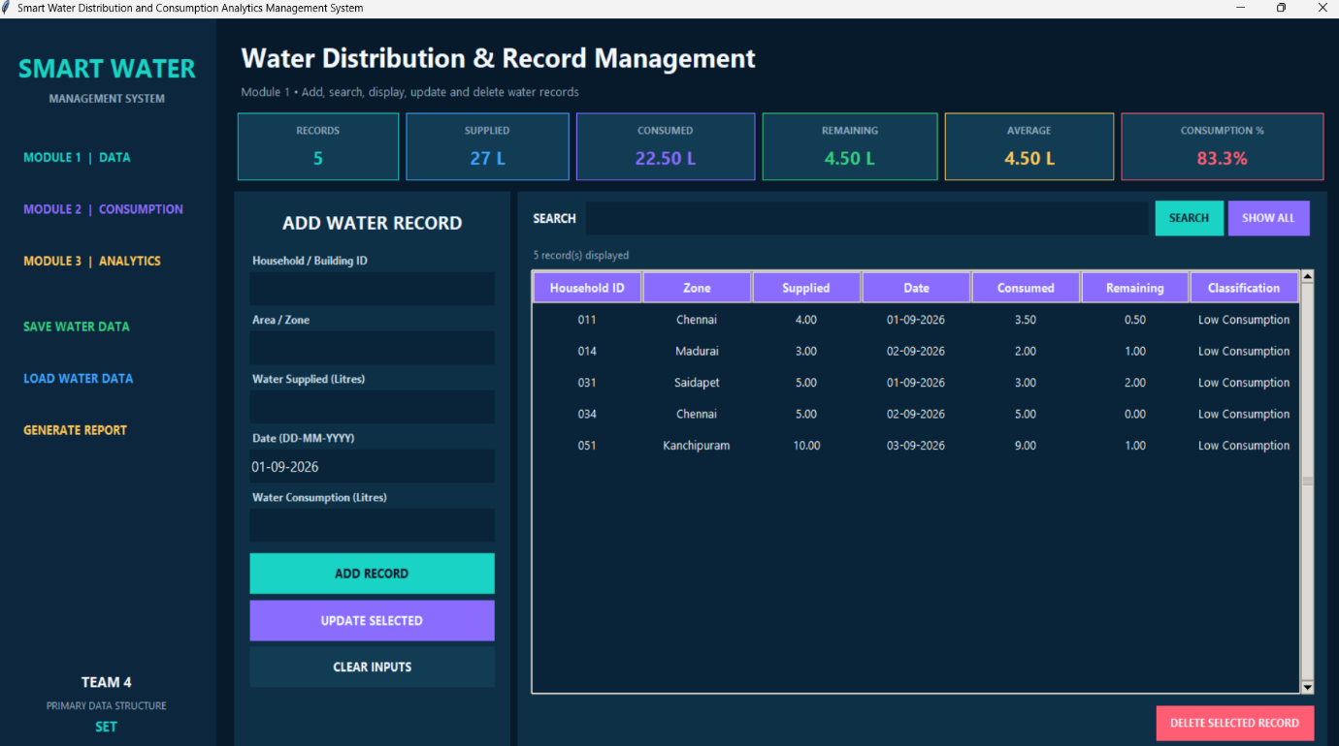

MODULE 2 – CONSUMPTION MONITORING
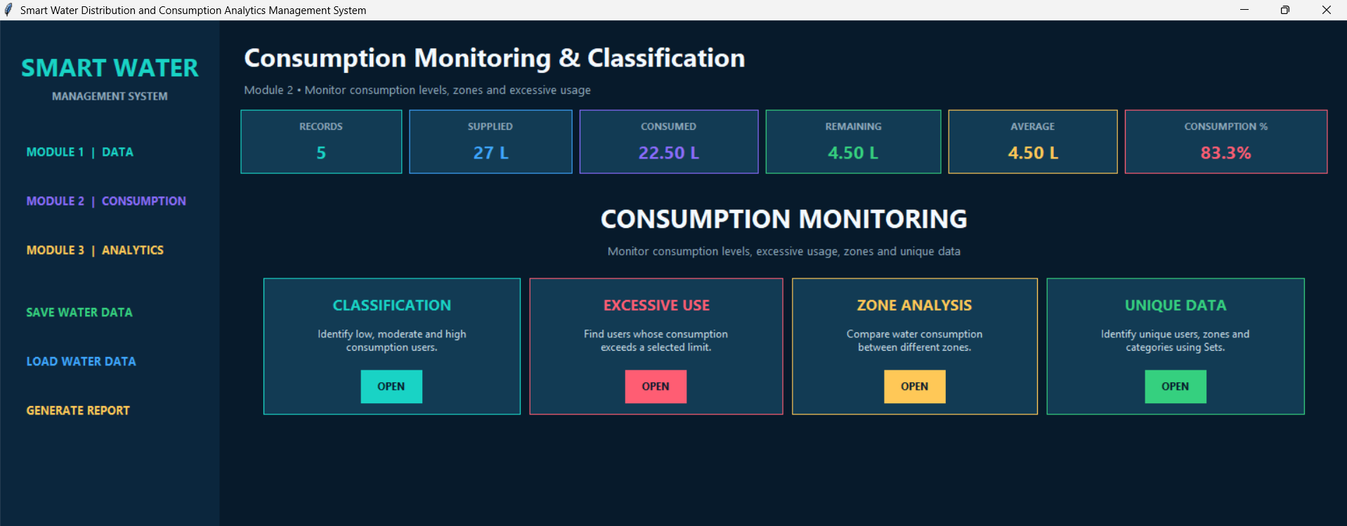
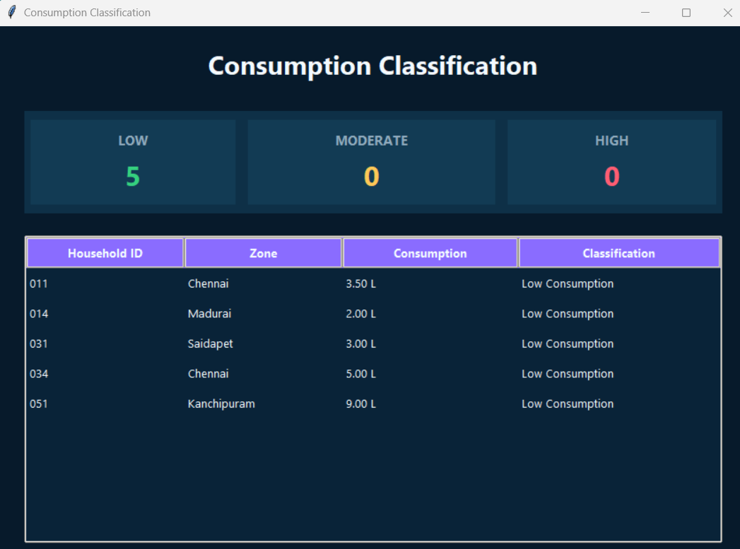

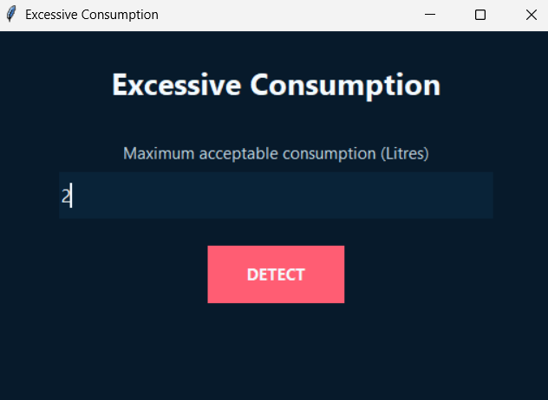

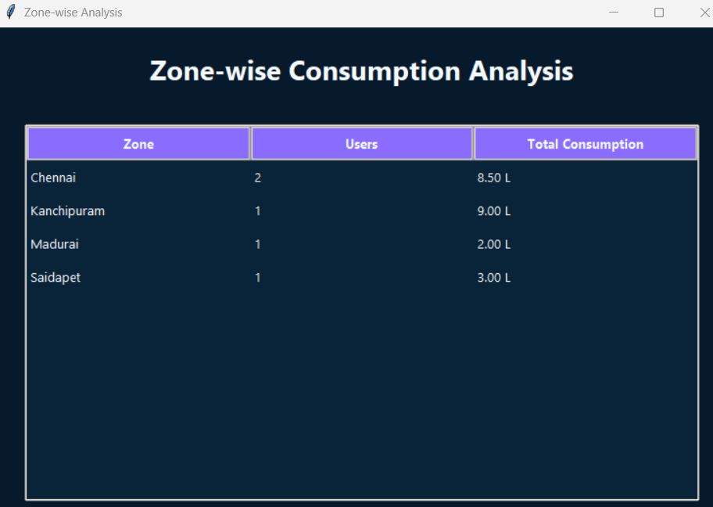

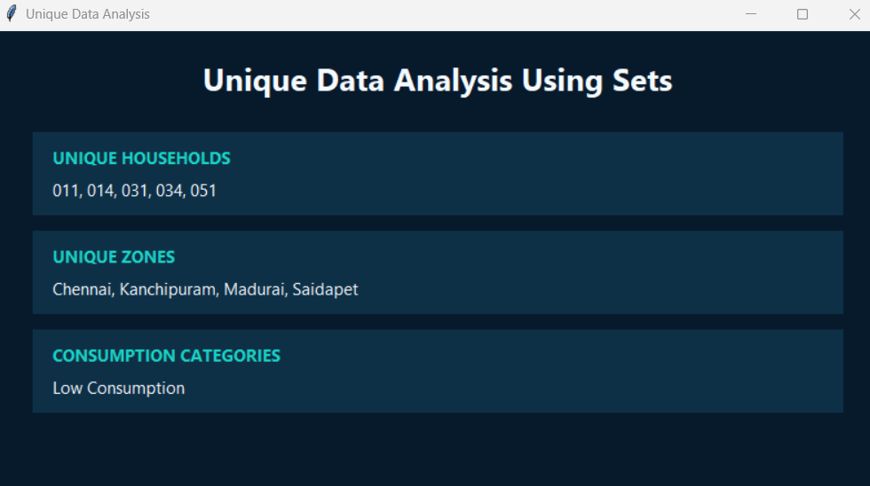

MODULE 3 – WATER ANALYTICS AND REPORT MANAGEMENT

